NETWORK SECURITY, MAINTENANCE AND TROUBLESHOOTING PROCESS

WIDE AREA NETWORK
TASK1: Draw a simple diagram (on paper or using an online tool like draw.io) showing how your phone connects to Instagram's servers from your home WiFi, including the ISP and at least two Wide Area Network (WAN) devices (like routers or switches) in the path.
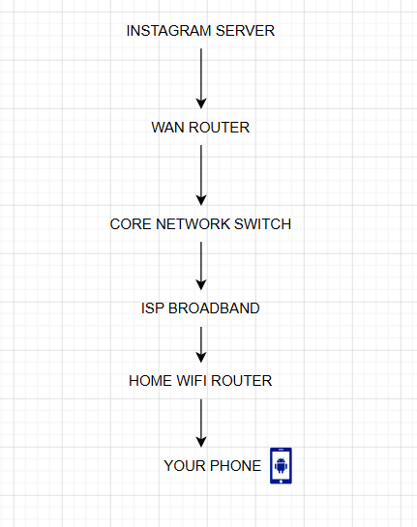
LABLES:
Phone → Home Wi-Fi Router → ISP → WAN Router → Core Network Switch → Instagram Server

TASK2: Create a table listing three types of WAN technologies (such as MPLS, Leased Line, and Broadband Internet) and compare them based on speed, cost, and where you might see them used in real life (e.g., Zomato office, IRCTC ticketing, your home).
WAN Technology | Speed | Cost | Real-Life Use
MPLS | High | Expensive | Zomato offices connecting different branches
Leased Line | Very High | Very Expensive | Banks, IRCTC ticket booking system
Broadband Internet | Medium to High | Low | Home internet connection

TASK3: Research and write a short explanation of how a VPN (Virtual Private Network) uses WANs to let you access apps like Spotify or YouTube securely from a public WiFi at a coffee shop.<br><br><em><strong>Hint:</strong> Focus on how the VPN creates a private tunnel over the public WAN.</em>
A VPN (Virtual Private Network) creates a secure and encrypted tunnel over the public internet (WAN). When I connect to public Wi-Fi at a coffee shop, the VPN encrypts my data before it travels across the internet. This protects my personal information and makes browsing apps like Spotify or YouTube more secure.
TASK4: Imagine Flipkart wants to connect its warehouses in Ahmedabad, Mumbai, and Delhi. Suggest which WAN technology would be best for them and justify your answer with two reasons.
Flipkart Warehouse WAN Solution
Answer
If Flipkart wants to connect its warehouses in Ahmedabad, Mumbai, and Delhi, I would recommend using MPLS (Multiprotocol Label Switching).
Reason 1
MPLS provides a fast and reliable connection between different warehouses.
Reason 2
It offers better security and stable performance for transferring order and inventory data.

